We are so excited to welcome you to By the Seashore! Here is some information about what our morning together will look like.

I am going to see By the Seashore, an outdoor performance by Arts on the Horizon.
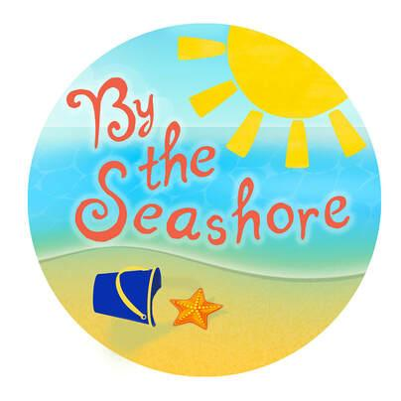

I will go to the Lee District Park in Alexandria, VA.
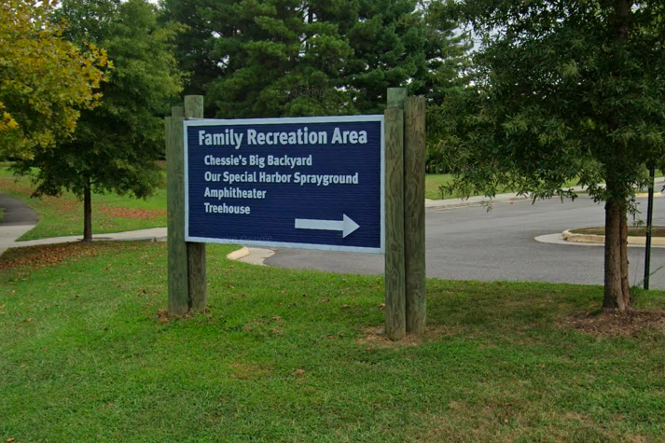
From Google Maps

My family members/guardians and I can get there by bus or car.
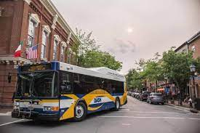
From visitalexandriava.com and and cars.usnews.com

When I arrive at the park, my family members and I will park and follow a trail to the Leonadus K. Plenty Amphitheater. The Leonadus K. Plenty Amphitheater is where the performance will take place.
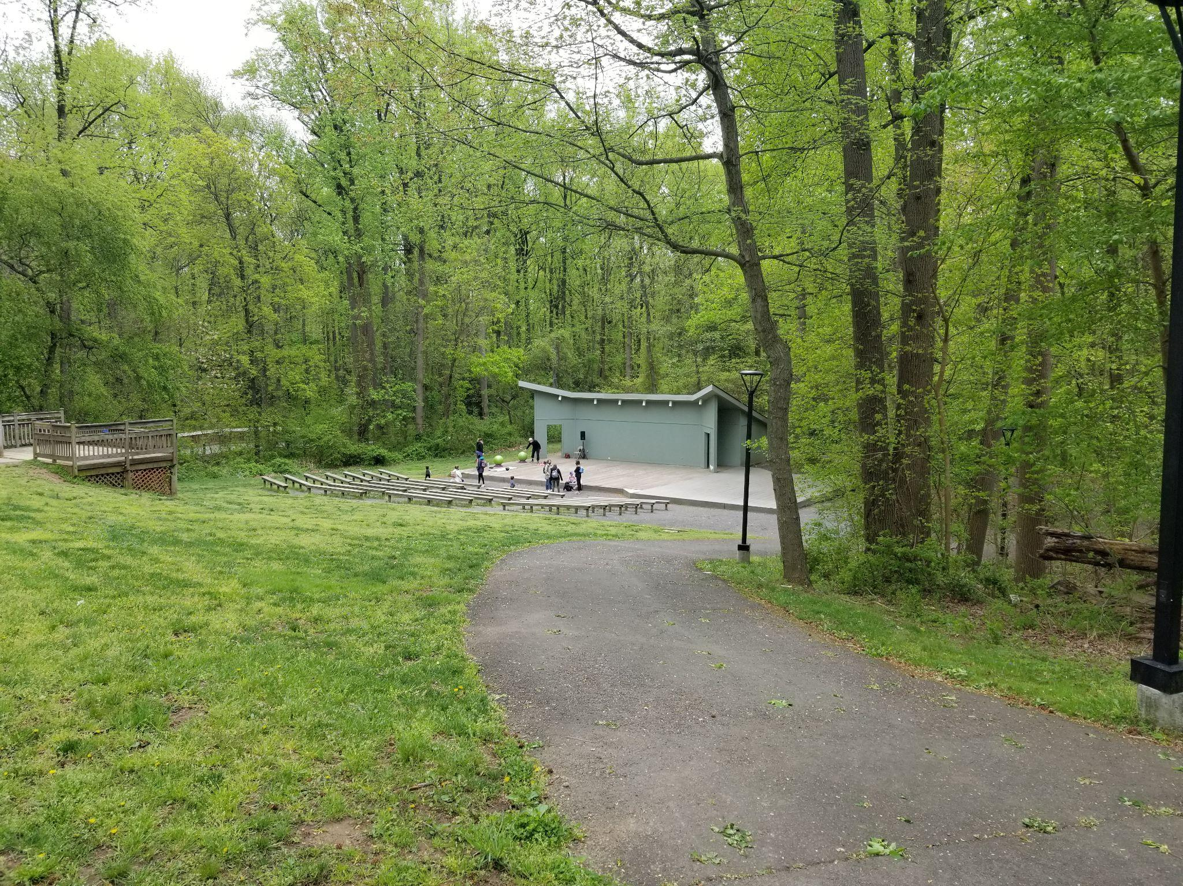
From Arts on the Horizon

When we arrive, I will be greeted by the house manager who will check our name off the list.

The house manager will hand us a bag with different things we can use during the show. These things will help us participate in the show while staying safe and socially distant from the actors. For example, there will be a textured fish prop in the bag that I can use to swim through the ocean. We will be able to take the bag home with us after the show.
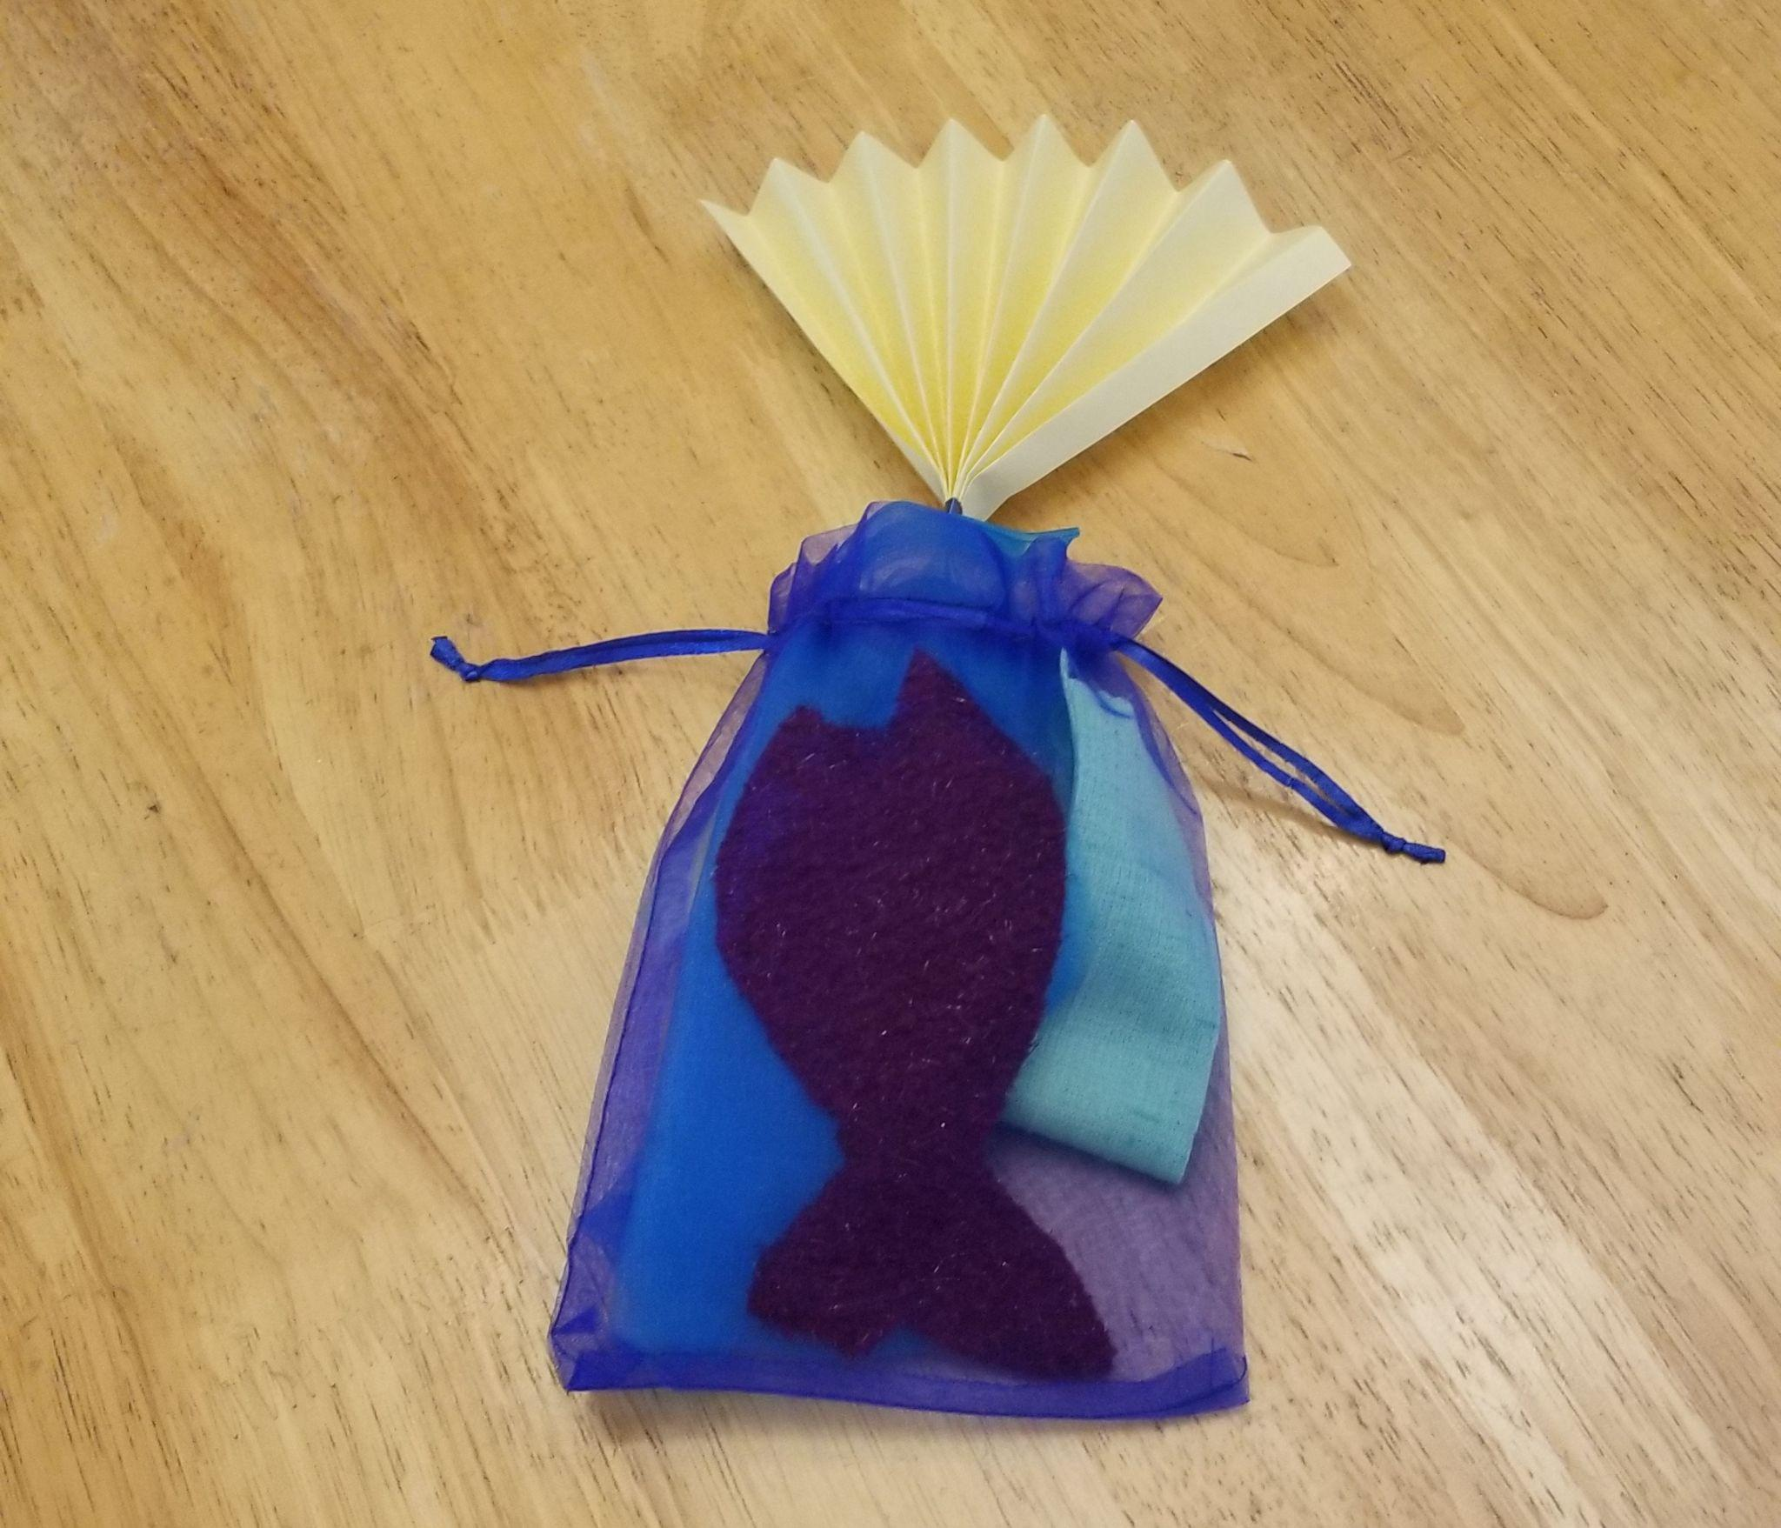
From Arts on the Horizon

Then, the house manager will show us where to enter the amphitheater. My family members and I will either sit on the benches in front of the amphitheater, or we will sit on chairs that we have brought. We will be at least 6 feet away from other families in the audience.
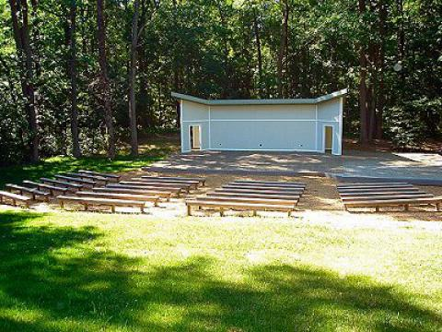
From www.fairfaxcounty.gov/

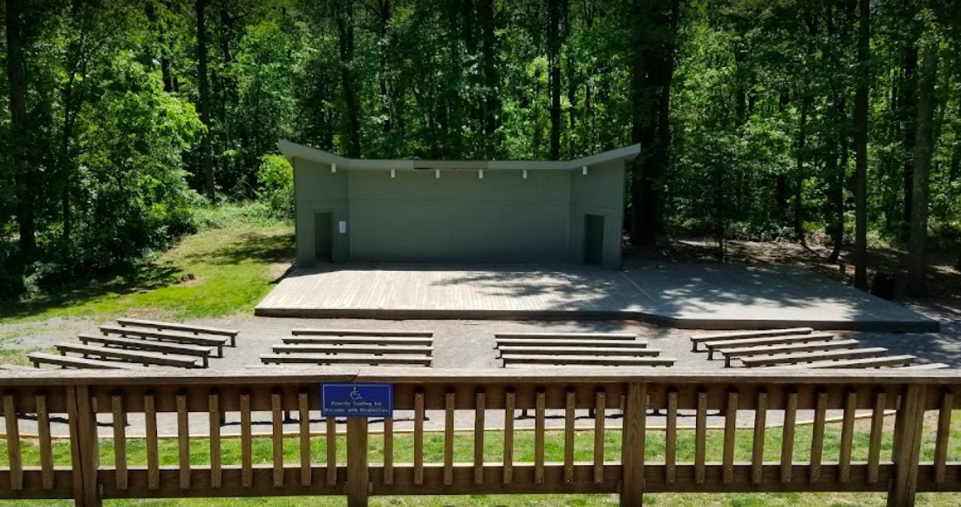
The entrance to the amphitheater is on a declining hill, so if anyone in my group needs wheelchair-accessible seating, someone from Arts on the Horizon will take us to a path leading to seats on the top of the hill.

From Google Maps

My family members will be wearing masks, and I will too if I am 2 or older.
From healthblog.uofmhealth.org

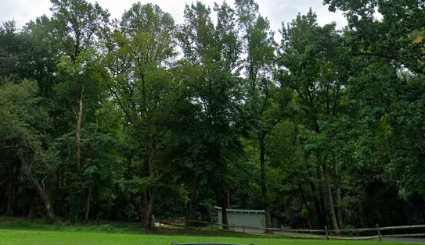
The performance will take place outdoors, so I might feel chilly or warm. I might also hear and feel the wind, and see animals and insects.

From Google Maps

If I need to use the restroom before, during, or after the performance, there are restrooms in another part of the park. My group and I can get there by crossing the parking lot and finding “Chessie’s Big Backyard”.
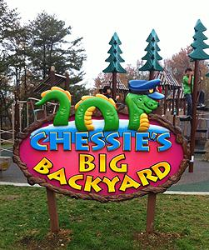
From fairfaxparkfoundation.org

Right before the show starts, the house manager will come out on stage to welcome everyone to the show. They will remind us to keep our masks on and stay socially distant from the actors and other groups in the audience.

During the show, I will hear sounds like seagull calls and ocean waves. The actors and puppets will sometimes make sounds when they move.

First, I will meet Baby Bird and a group of crabs - some of the crabs will be small and some of them might look very big! We will explore a big piece of fabric that moves and rustles like the ocean. Two of the crabs will have a tug of war with some seaweed. One of the crabs will tap dance.
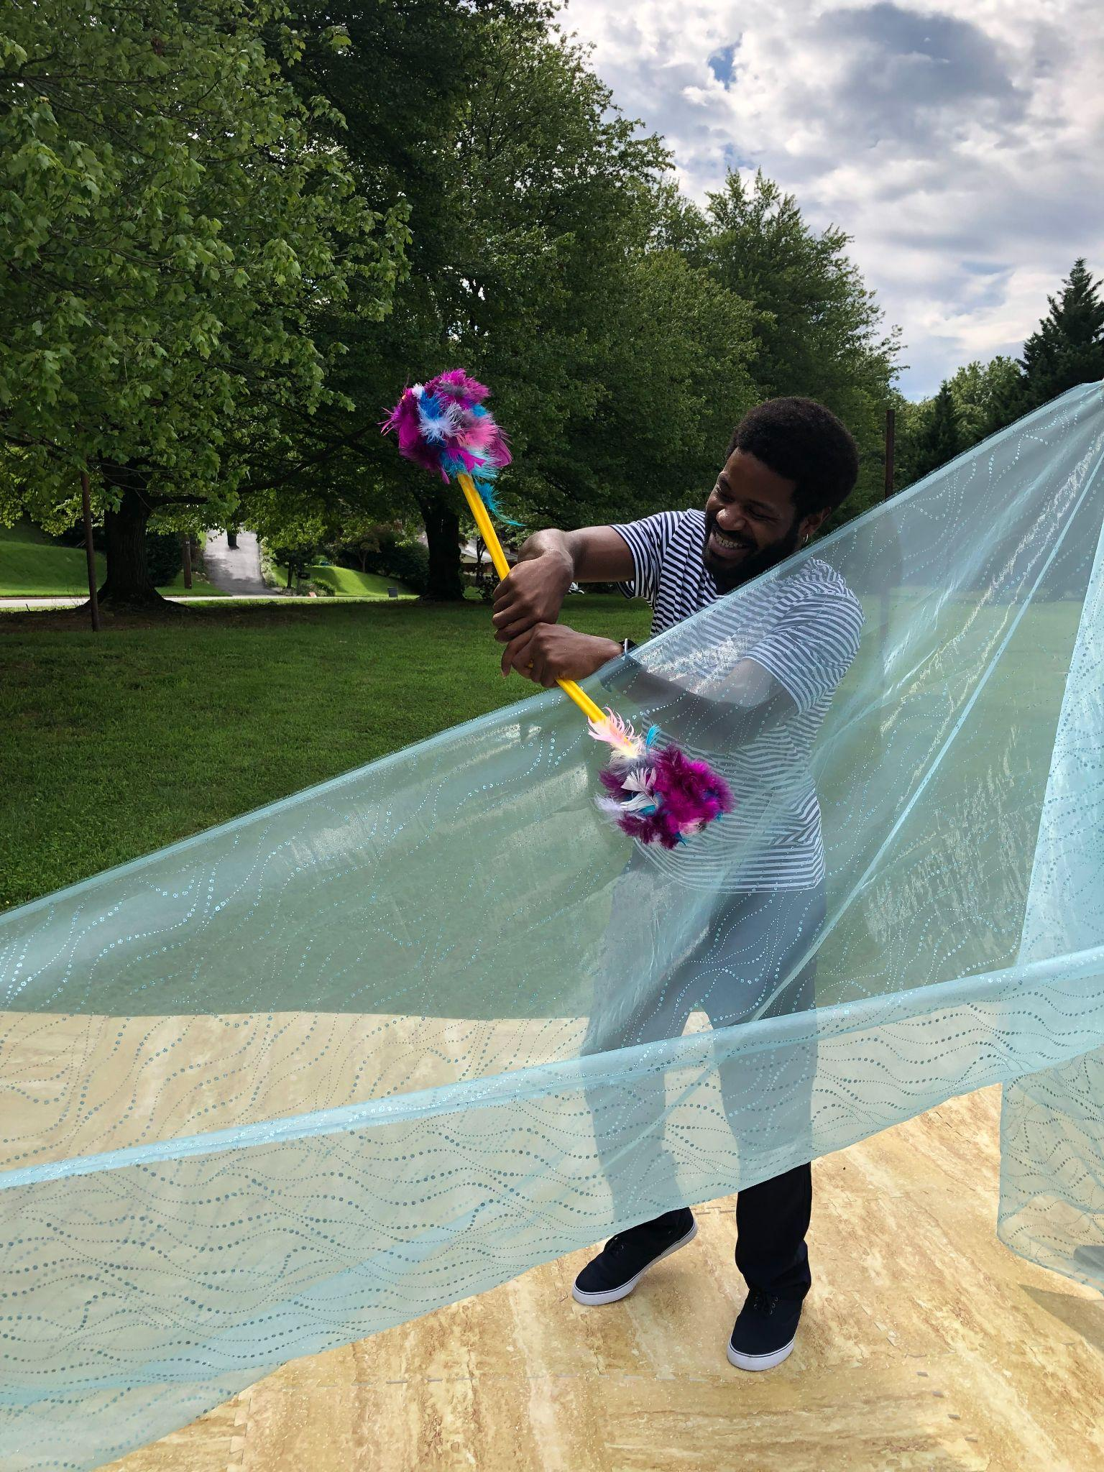
From Arts on the Horizon

Then, we will explore the sky. I will see big, fluffy clouds and watch a banner attached to a plane wave in the wind. I will feel a gentle breeze from the paper fans. A small bird and a big mama bird will join Baby Bird in the sky.
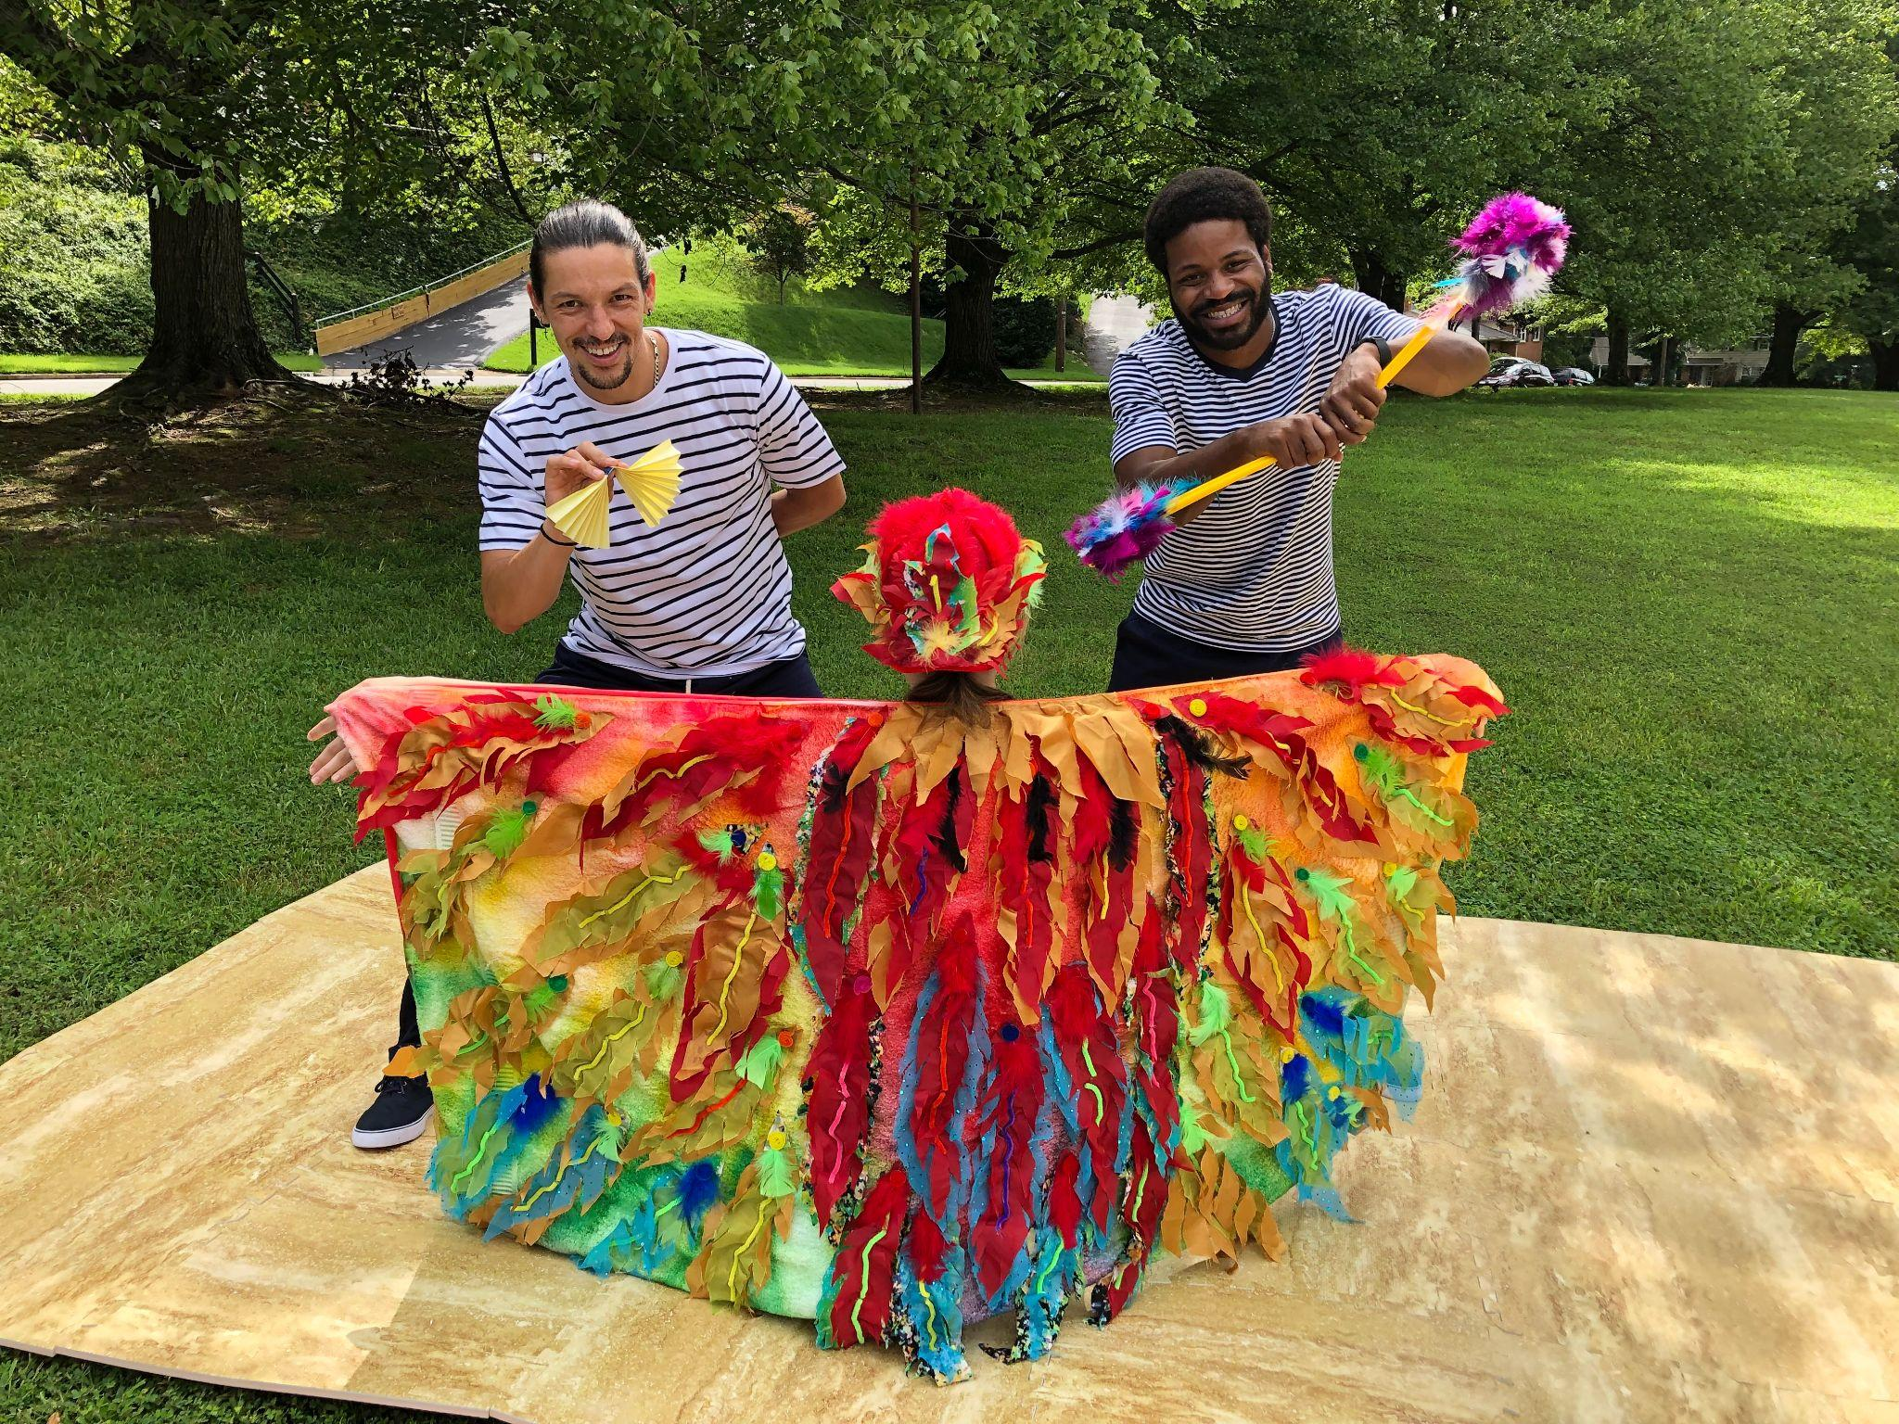
From Arts on the Horizon

We will follow Baby Bird as far as the surface of the water, and then Baby Bird will rejoin their family in the sky. The rest of the audience and I will stay under the sea for the rest of the show. I will see seaweed sway in the water and meet different creatures living in the sea - including little fishes, a sea turtle, and puffer fish and jellyfish.

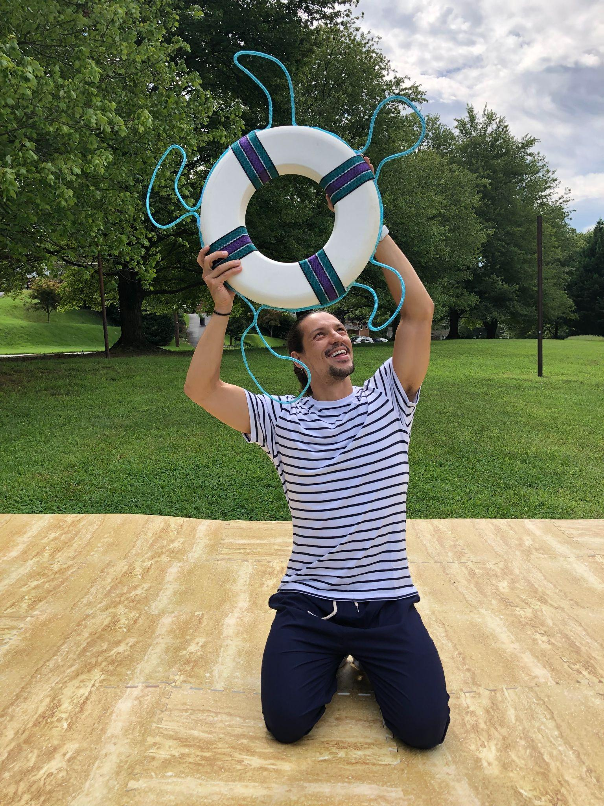
From Arts on the Horizon

After meeting these creatures under the sea, I will meet a large, shimmering fish. This fish may look bright in the sun. After we explore together, the large, shimmering fish will rush offstage to see more of the ocean. Once the fish leaves, the show will be over.

After the show, the house manager will get back on stage. They will thank the audience for coming and remind us that we can bring our prop bags home.

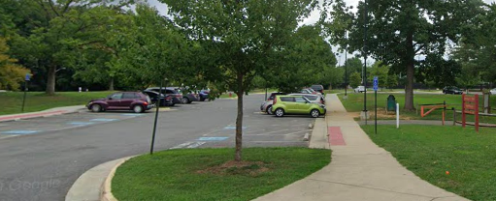
I will leave the amphitheater with my group by following the trail back to the parking lot. I might see other people from different parts of the park in the parking lot.

From Google Maps

We can’t wait for you to join us at the seashore!

