Q-Tip Snowflakes
Level of Difficulty: Easy
Even older toddlers can glue Q-Tips, you don't need to cut the Q-tips to make snowflakes, but if you want to make different sizes you could always cut them ahead of time. Put some glue in a shallow dish so your toddler(s) can just dip the swab.
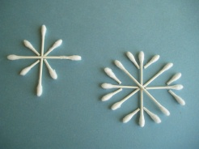
Here's what you'll need...
•Blue construction paper or cardstock (or whatever color of background you'd like)
•Q-Tips
•Glue
•Scissors (optional)
Here's how to make it...
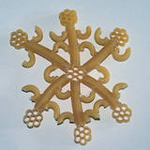
1. Cut your Q-Tips in various sizes or, just use them whole for younger children. Use them to create beautiful snowflakes on your blue paper. Glue all of your Q-Tips in place and you're finished! Remember, no two snowflakes look alike!

Noodle Snowflake Craft

Materials Needed:
- Noodles
- Wax Paper
- Craft Glue
- Thread

Instructions:
For this craft, you can use whatever shape and size of noodle you want. Some of my favorites are elbow macaroni, wagon wheels, rotini, and bowties.

- Lay a piece of wax paper down on your work area. Because you will need to be generous with the glue, the wax paper will not only protect the table from glue drips, but it should also be easily peeled away from your dried snowflake.
- To make this craft, simply experiment by gluing one or several different kinds of pasta together to form a snowflake. There is no right or wrong way to arrange the noodles to create a snowflake. Remember, there are no two snowflakes alike either, so be unique and have fun!
- Leave the noodle snowflake sitting on the wax paper until the glue is completely dry and then carefully pull the snowflake away from the wax paper. Finally, you can use a piece of thread to hang up your snowflake!

